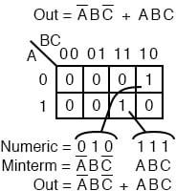
- Identify the minterm (product term) term to be mapped.
- Write the corresponding binary numeric value.
- Use binary value as an address to place a in the K-map
- Repeat steps for other minterms (P-terms within a Sum-Of-Products).
1

A Boolean expression will more often than not consist of multiple minterms corresponding to multiple cells in a Karnaugh map as shown above. The multiple minterms in this map are the individual minterms which we examined in the previous figure above.
The point we review for reference is that the 1s come out of the K-map as a binary cell address which converts directly to one or more product terms.
By directly we mean that a corresponds to a complemented variable, and a corresponds to a true variable. Example: converts directly to A’BC’.
There was no reduction in this example. Though, we do have a Sum-Of- Products result from the minterms.
Referring to the above figure, Let’s summarize the procedure for writing the Sum-Of-Products reduced Boolean equation from a K-map:
010
1
0

- Form largest groups of | 1 | s possible covering all minterms. Groups must be
a power of 2.
- Write binary numeric value for groups.
- Convert binary value to a product term.
- Repeat steps for other groups. Each group yields a p-terms within a Sum- Of-Products.

Nothing new so far, a formal procedure has been written down for dealing with minterms. This serves as a pattern for dealing with maxterms.
Next we attack the Boolean function which is 0 for a single cell and 1s for all others.

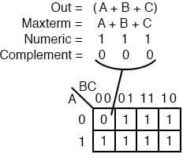

Maxterm
A maxterm is a Boolean expression resulting in a 0 for the output of a single cell expression, and 1s for all other cells in the Karnaugh map, or truth table. The illustration above left shows the maxterm (A+B+C), a single sum term, as a single 0 in a map that is otherwise 1s.
If a maxterm has a single 0 and the remaining cells as 1s, it would appear to cover a maximum area of 1s.
There are some differences now that we are dealing with something new, maxterms. The maxterm is a 0, not a 1 in the Karnaugh map. A maxterm is a
sum term, |  | (A+B+C) |  | in our example, not a product term. It also looks strange
that | (A+B+C) |  | is mapped into the cell |  | 000 | .

For the equation | Out=(A+B+C)=0 |  |  |  |  |  | , all three variables |  |  | (A, B, C) |  | must
individually be equal to |  |  | 0 | . Only |  | (0+0+0)=0 |  | will equal |  | 0 | . Thus we place our
sole 0 for minterm |  | (A+B+C) |  |  | in cell |  | A,B,C=000 |  | in the K-map, where the inputs
are all 0 .
This is the only case which will give us a 0 for our maxterm. All other cells contain 1s because any input values other than ((0,0,0) for (A+B+C) yields 1s upon evaluation.
Referring to the above figure, the procedure for placing a maxterm in the K- map is:

- Identify the Sum term to be mapped.
- Write corresponding binary numeric value.
- Form the complement
- Use the complement as an address to place a  - Repeat for other maxterms (Sum terms within |  |  | 0 in the K-map
 |  |  | Product-of-
 | Sums | expression).
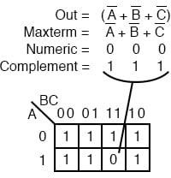

Another maxterm
is shown above. Numeric
corresponds

to . The complement is 111. Place a for maxterm in
A’+B’+C’
(A’+B’+C’)
0
000
A’+B’+C’
this cell (1,1,1) of the K-map as shown above.
111 |  | ?
 | (0+0+0)

Why should When
 | (A’+B’+C’)
A’+B’+C’ |  | is | (1’+1’+1’)

cause a
, all
1
0
to be in cell s in, which is

after taking

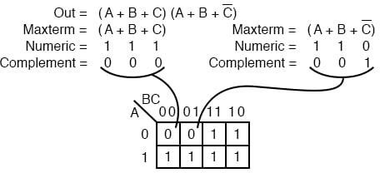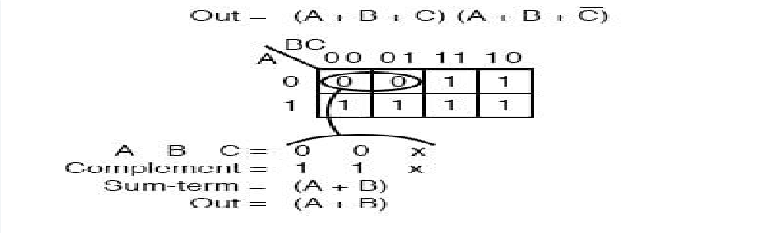complements, we have the only condition that will give us a 0. All the 1s are
complemented to all 0s, which is when ORed.
0

A Boolean Product-Of-Sums expression or map may have multiple maxterms
111
(A+B+C)

as shown above. Maxterm
(0,0,0)
0
yields numeric
which complements

to 000, placing a
110
in cell
. Maxterm
yields

numeric
(A+B+C’)
which complements to 001, placing a
in cell (0,0,1).

Now that we have the k-map setup, what we are really interested in is showing how to write a Product-Of-Sums reduction. Form the 0s into groups. That would be a group of two below. Write the binary value corresponding to the sum-term which is (0,0,X).
0
X
1
C
both | 0
(1,1,X)

Both A and B are
C
0
for the group. But, is
and
so we write an
as a

place holder for
(A+B)
. Form the complement
. Write the Sum-

term
discarding the
and the
which held its’ place.

In general, expect to have more sum-terms multiplied together in the Product- Of-Sums result. Though, we have a simple example here.
X
C

Let’s summarize the procedure for writing the Product-Of-Sums Boolean reduction for a K-map:

- Form largest groups of | 0 | s possible, covering all maxterms. Groups must
be a power of 2.
- Write binary numeric value for group.
- Complement binary numeric value for group.
- Convert complement value to a sum-term.
- Repeat steps for other groups. Each group yields a sum-term within a Product-Of-Sums result.

Examples
Example:
Simplify the Product-Of-Sums Boolean expression below, providing a result in POS form.

Solution:
Transfer the seven maxterms to the map below as 0s. Be sure to complement the input variables in finding the proper cell location.

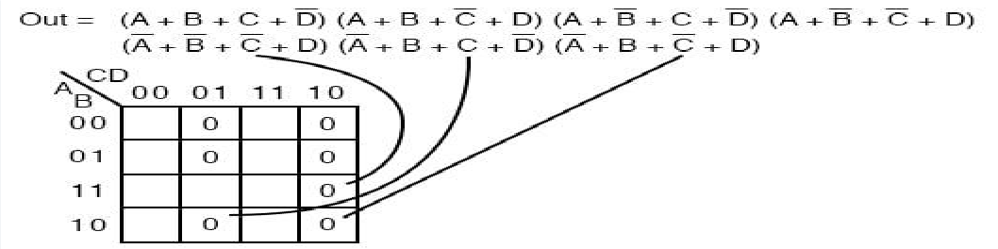

We map the 0s as they appear left to right top to bottom on the map above. We locate the last three maxterms with leader lines..
Once the cells are in place above, form groups of cells as shown below. Larger groups will give a sum-term with fewer inputs. Fewer groups will yield fewer sum-terms in the result.

We have three groups, so we expect to have three sum-terms in our POS result above. The group of 4-cells yields a 2-variable sum-term. The two groups of 2-cells give us two 3-variable sum-terms.
Details are shown for how we arrived at the Sum-terms above. For a group, write the binary group input address, then complement it, converting that to the Boolean sum-term. The final result is product of the three sums.

